Project Testing
Performance Testing
Date | 29 September 2026
Team No. | 05
Project Name | AI WeatherWise
Maximum Marks | 5 Marks
Performance Testing
Performance testing evaluates how the system behaves under expected and peak load conditions. The sections below document the planned testing approach, testing tool, target APIs, scenarios, expected outcomes, and evidence for the AI WeatherWise backend.
Step 1: Testing Overview
Field | Details
Testing Tool Used | Thunder Client
Type of Testing | API Performance / Load Testing
Target Module / API | User Registration, Login, Weather Retrieval, and Weather Recommendation APIs
Test Environment | Local development environment
Test Date | 29 September 2026

Step 2: Test Scenarios
S.No | Test Scenario /  Description | No. of Virtual  Users | Duration  (sec) | Expected Outcome
1 | User Registration API | 10 | 60 | API should successfully process registration requests and return an appropriate response without errors.
2 | User Login API | 10 | 60 | API should authenticate valid users and return the appropriate response without errors.
3 | Weather API – Chennai | 10 | 60 | API should retrieve current weather information successfully with stable response handling.
4 | Weather Recommendation API | 10 | 60 | API should return a weather-based recommendation; fallback handling should maintain the response when the external AI service is unavailable.
Testing Scope
The performance-testing scope covers the four core API operations demonstrated for AI WeatherWise. The objective is to observe response behavior under a defined request load while checking that authentication, weather retrieval, and recommendation endpoints continue to respond correctly.
Note: The virtual-user and duration values above are the planned performance-test scenarios. They should not be presented as completed load-test measurements unless the load test is actually executed.

Step 3: Performance Test Results
S.No | Metric | Target Value | Actual Value | Status | Remarks
1 | Response Time  (Avg) | < 2 seconds | Not measured | Not Executed | Requires an actual load/performance run.
2 | Response Time  (Max) | < 5 seconds | Not measured | Not Executed | Requires an actual load/performance run.
3 | Throughput  (Req/sec) | Stable throughput expected | Not measured | Not Executed | Requires an actual load/performance run.
4 | Error Rate | < 1% | Not measured | Not Executed | Requires an actual load/performance run.
Step 4: Observations & Analysis
The AI WeatherWise backend was functionally tested using Thunder Client for registration, login, Chennai weather retrieval, and the recommendation endpoint. The recommendation workflow includes fallback handling when the external AI service is unavailable. The performance metrics above are intentionally left as not measured because a dedicated multi-user load test was not executed in the current project workflow.
The performance test plan can be executed in a suitable load-testing environment in a later stage to record average response time, maximum response time, throughput, error rate, CPU utilization, and memory utilization.

Step 5: Screenshots / Evidence
Add the project testing screenshots below. Keep sufficient space for the screenshots to be inserted later.
Evidence 1 – Performance Testing / API Request Setup
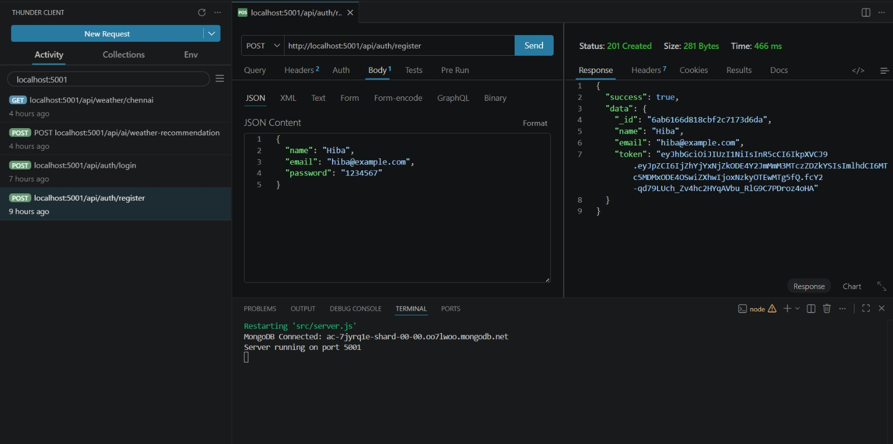

Evidence 2 – Test Result / Response Evidence
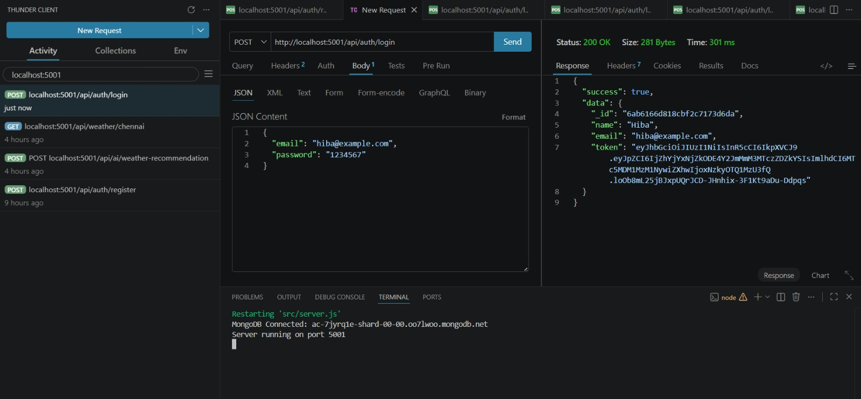

Project: AI WeatherWise | Team No: 05

